**Mohammd Shaban Vakeel**

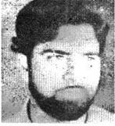

**About :**Alsafa owner Shaban Vakil belonged to Seelu Sopore and was an income tax lawyer before starting the newsparer. He was an outspoken man who had been involved in the al-Fatah movement of mid 1960’s. He also was running an NGO –al-Safa Forum. As a new entrant,al-Safa created it’s own niche and offered readers a break from the routine journalism. Vakil had aggressively taken up the state of human rights with the all party delegation that Rajeev Gandhi led to Srinagar when the Jagmohan replaced Dr Abdullah coalition government.

**Murdered on:** 23 April 1991.

**Attack details:**In one of the first casualties the media in Kashmir suffered was killing of the Alsafa owner and editor, Mohammad Shaban Vakil. On April 23, 1991 he was shot dead in his office by militant.

**Reason to him target :** He was a journalist and used to publish.

**Occupation:** He was owner of al- safa newspaper and also income tax lawyer.

**Belief:** They want to provide truth and fact news of the people.

**URL :** <https://kashmirlife.net/silenced-shaban-vakil-10785/>

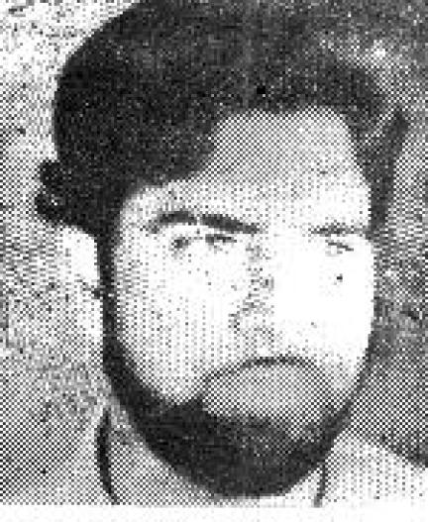

**Ghulam Muhammad Lone**

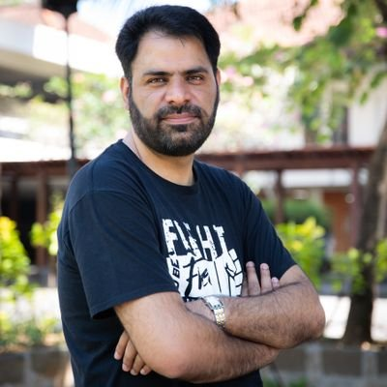

**About:** Ghulam Mohammad Lone, a freelance print reporter, who also wrote for the English newspaper Greater Kashmir. Lone, a newspaper salesman and freelance journalist who contributed to several publications. His seven-year-old son in their home in Kangan, Kashmir.

**Murdered on: August 29, 1994.**

**Attack details:** A group of masked gunmen who also fatally shot his seven-year-old son in their home in Kangan, Kashmir.

**Reason to him target:** Lone had reportedly received death threats from a security agent for his coverage of troop movements in Kashmir.

**Occupation:** , A newspaper salesman and journalist.

**Belief:** Ghulam Mohammad Lone was a freelance print reporter.

**Saidan Shafi**

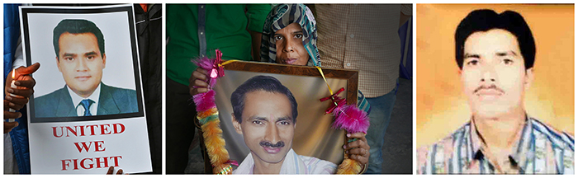

**About:** Shafi a reporter for Doordarshan TV, the official Indian television network, for “Kashmir File,” a weekly news program. Shafi ran a program that was critical of the Kashmiri separatists. Following his report, Shafi reportedly received death threats from separatists for his ‘biased’ reportage.

**Murdered on: | March 16, 1997.**

**Attack details:** He was shot in an ambush by two gunmen in Srinagar, Kashmir. His personal security guard also was killed in the attack.

**Reason to him target:**  Shafi reportedly received death threats from separatists for his biased reportage.

**Occupation:**  Reporter for Doordarshan TV, the official Indian television network.

**Belief:** The language a reporter writes in and, most importantly, what they are writing about—especially if it challenges the powerful increase the vulnerability.

**Parvaz Mohammad Sultan**

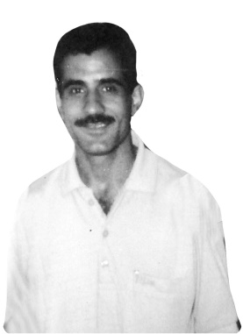

**About:**  Parvaz hailed from a remote village of Khiram in south Kashmir. A talented guy, he tried his hand in writing and soon carved a space for him in the vernacular press. He worked in Al Safa, and then a leading Urdu daily published from Srinagar and also wrote analytical pieces for Urdu weekly Chattan. Parvaz had also a stint as a reporter with Congress mouthpiece *Quami Awaz*, published from Delhi. However, in 2000 he launched his own news service to give fillip to feature writing and received an encouraging response from the readers and news organizations. He also edited a local newspaper *Wattan*, though unofficially

His 29-year-old wife Shameema was a broken soul who mustered courage to get a government job as compensation to her husband’s death. She needed the job to grapple with the challenge of bringing up three small children and ensure their education.

**Murdered on :** January 31, 2003.

**Attack details:** Two unidentified gunmen on Friday evening shot dead Parvaz Mohammed Sultan. The two gunmen came inside the office and were talking to Parvaz.

**Reason to him target:** The motive behind Parvaz’s killing continues to remain a mystery, as has been the case with hundreds of killings added to the accounts of “unidentified” gun men. Parvaz’s death was connected to the intergroup rivalry within a prominent militant organization.

**Occupation:** Editor of Urdu daily *Alsaffa News* and Reporter.

**Belief:** An encouraging response from the readers and news organizations.